****Assignment Part 1****

Upon seeing how Helen Newing documents her article search, I learned how to conduct my literature search and decided to try on the theme of human-computer interaction.

University of the Arts London Library

A search of my university library’s online catalogue on ‘human-computer interaction’ returned 249 results. This is a huge amount, so in order to narrow the search, I added design and searched again, and then it returned 106 results. However, there is still a lot. Therefore, I refined by date, which is between 2017 to 2023. Finally, I got 26 results. I think this amount is just right.

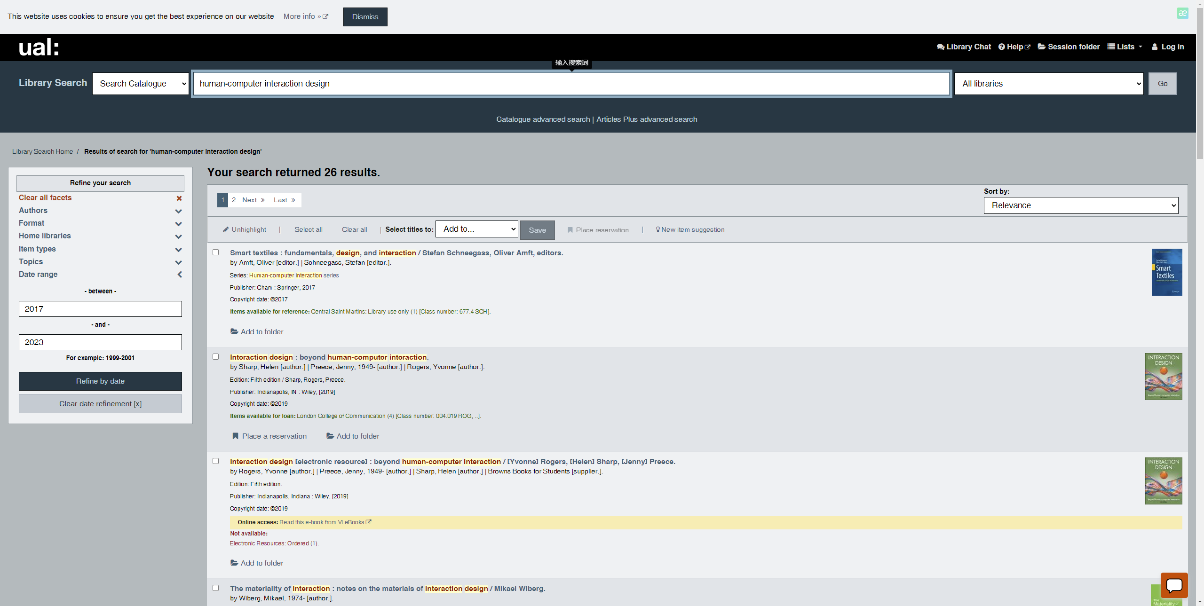

Google Scholar

I still used the human-computer interaction as the keyword and searched it, but I got over 1 million results. They include too many different kinds of fields and subjects. It is difficult to read. Therefore, I still need to refine them.

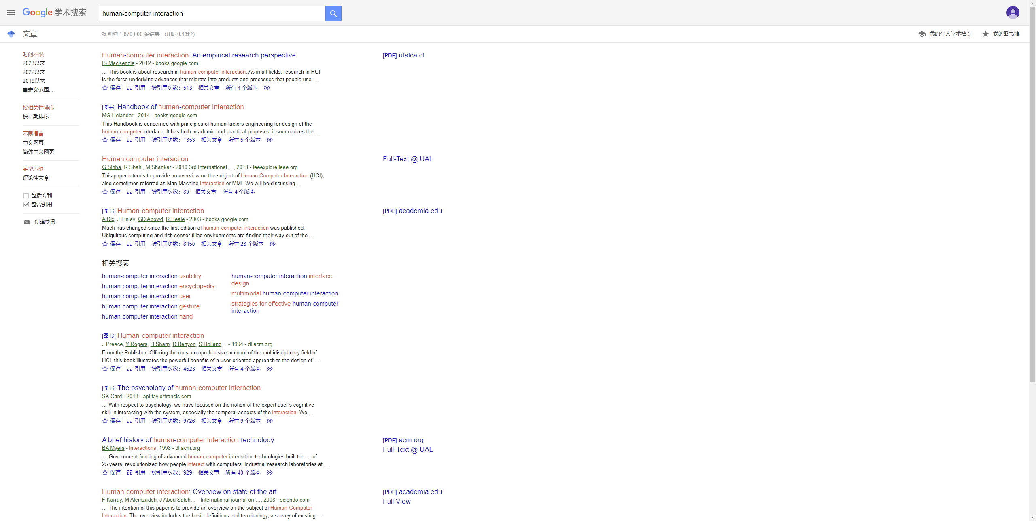

Firstly, I would like to set a range for searching. So, I changed the keyword to the embodiment of human-computer interaction gesture recognition in design, then I got 17900 results - better, but still too many.

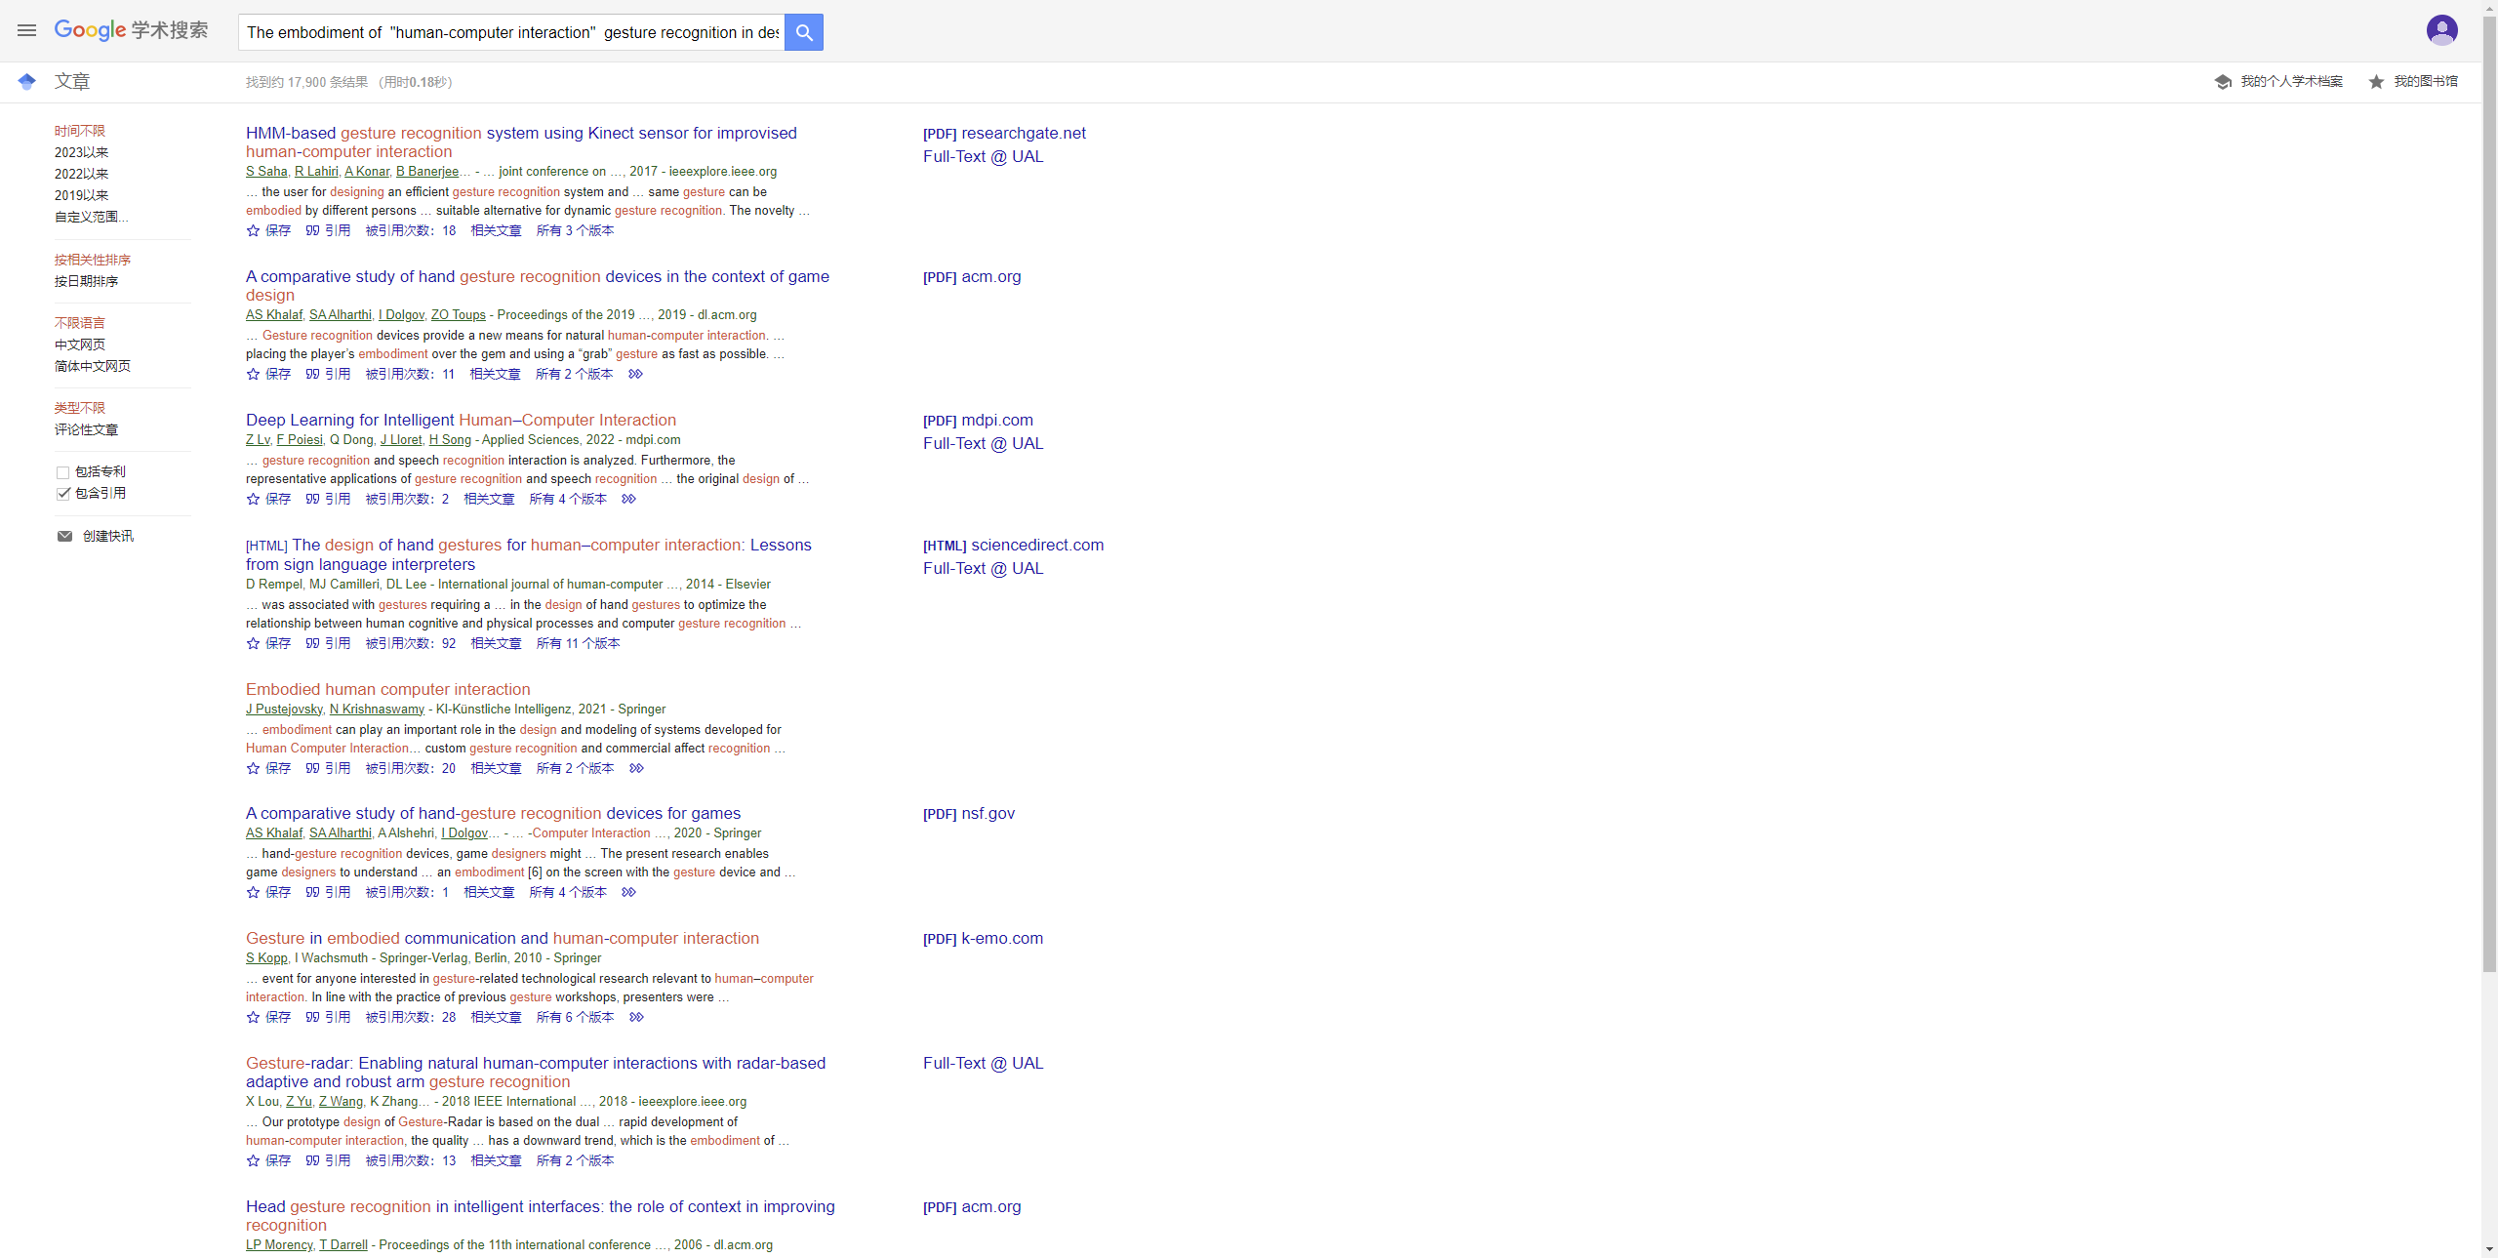

Secondly, I chose the articles in 2023, then I got 238 results. I think refining by date is a good way to reduce the quantity and get the latest information.

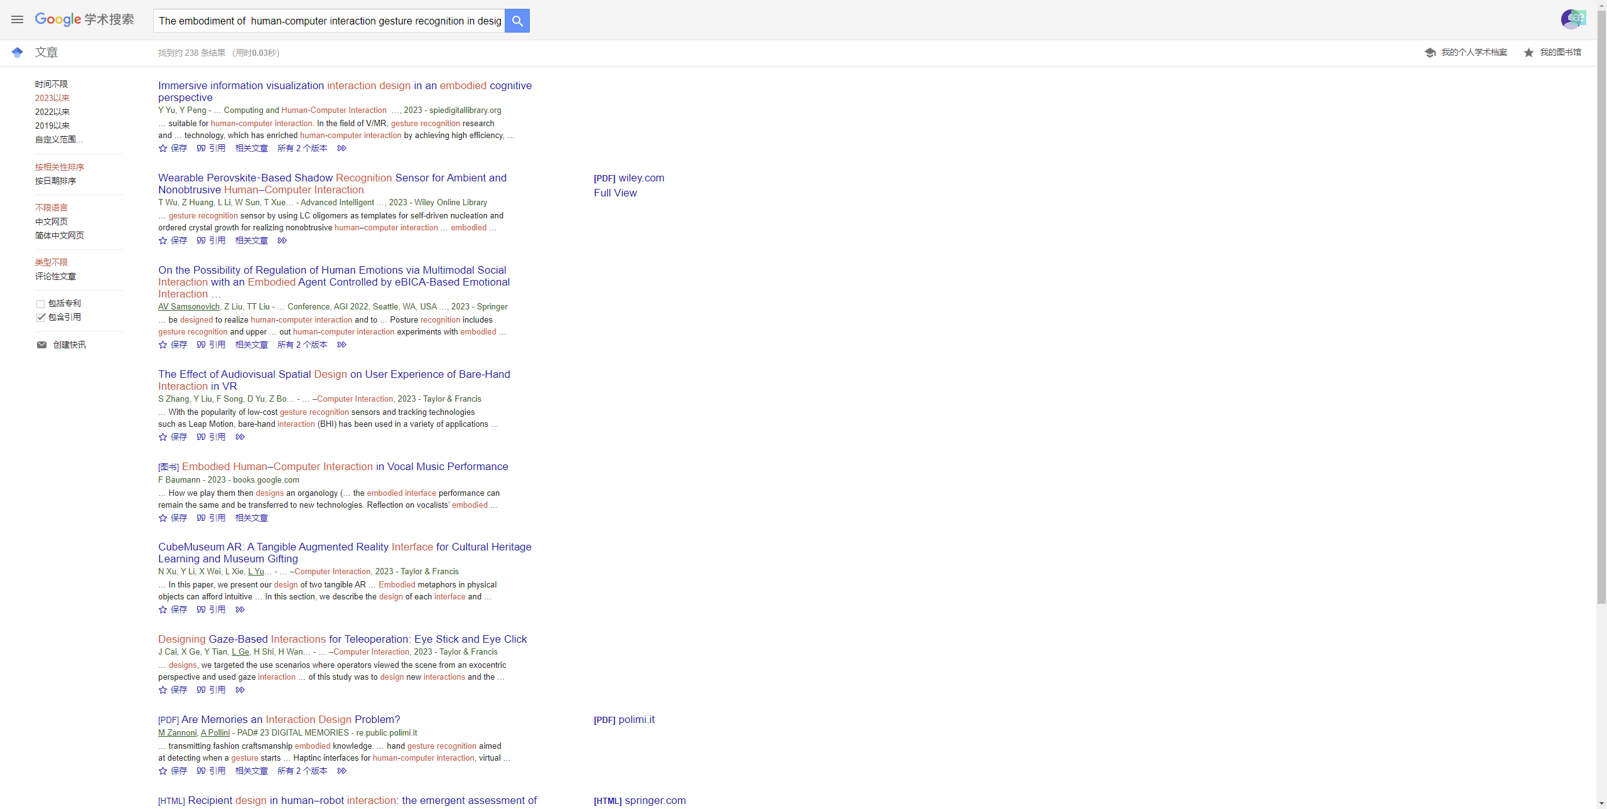

I thought 211 results were still a lot. So, finally, I added VR as the keyword, and then I got 137 results.

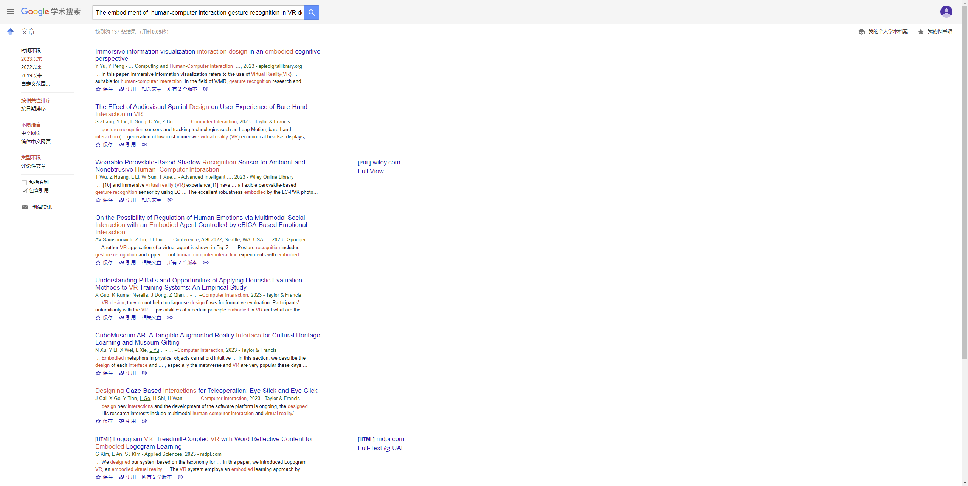

Google Books

A search of google books on ‘Human-computer interaction’ produced too many results (the website did not show me how many hits, but it was over 10 pages). Then I searched another keyword on ‘the embodiment of human-computer interaction gesture recognition in VR design’ and set the time in the 21st century, I got 18 hits(Google books still did not show me the number, so I counted it). According to the description, except for the last five books that are not related to this topic, the first 13 books have talked about this topic and some marked which pages showed the content.

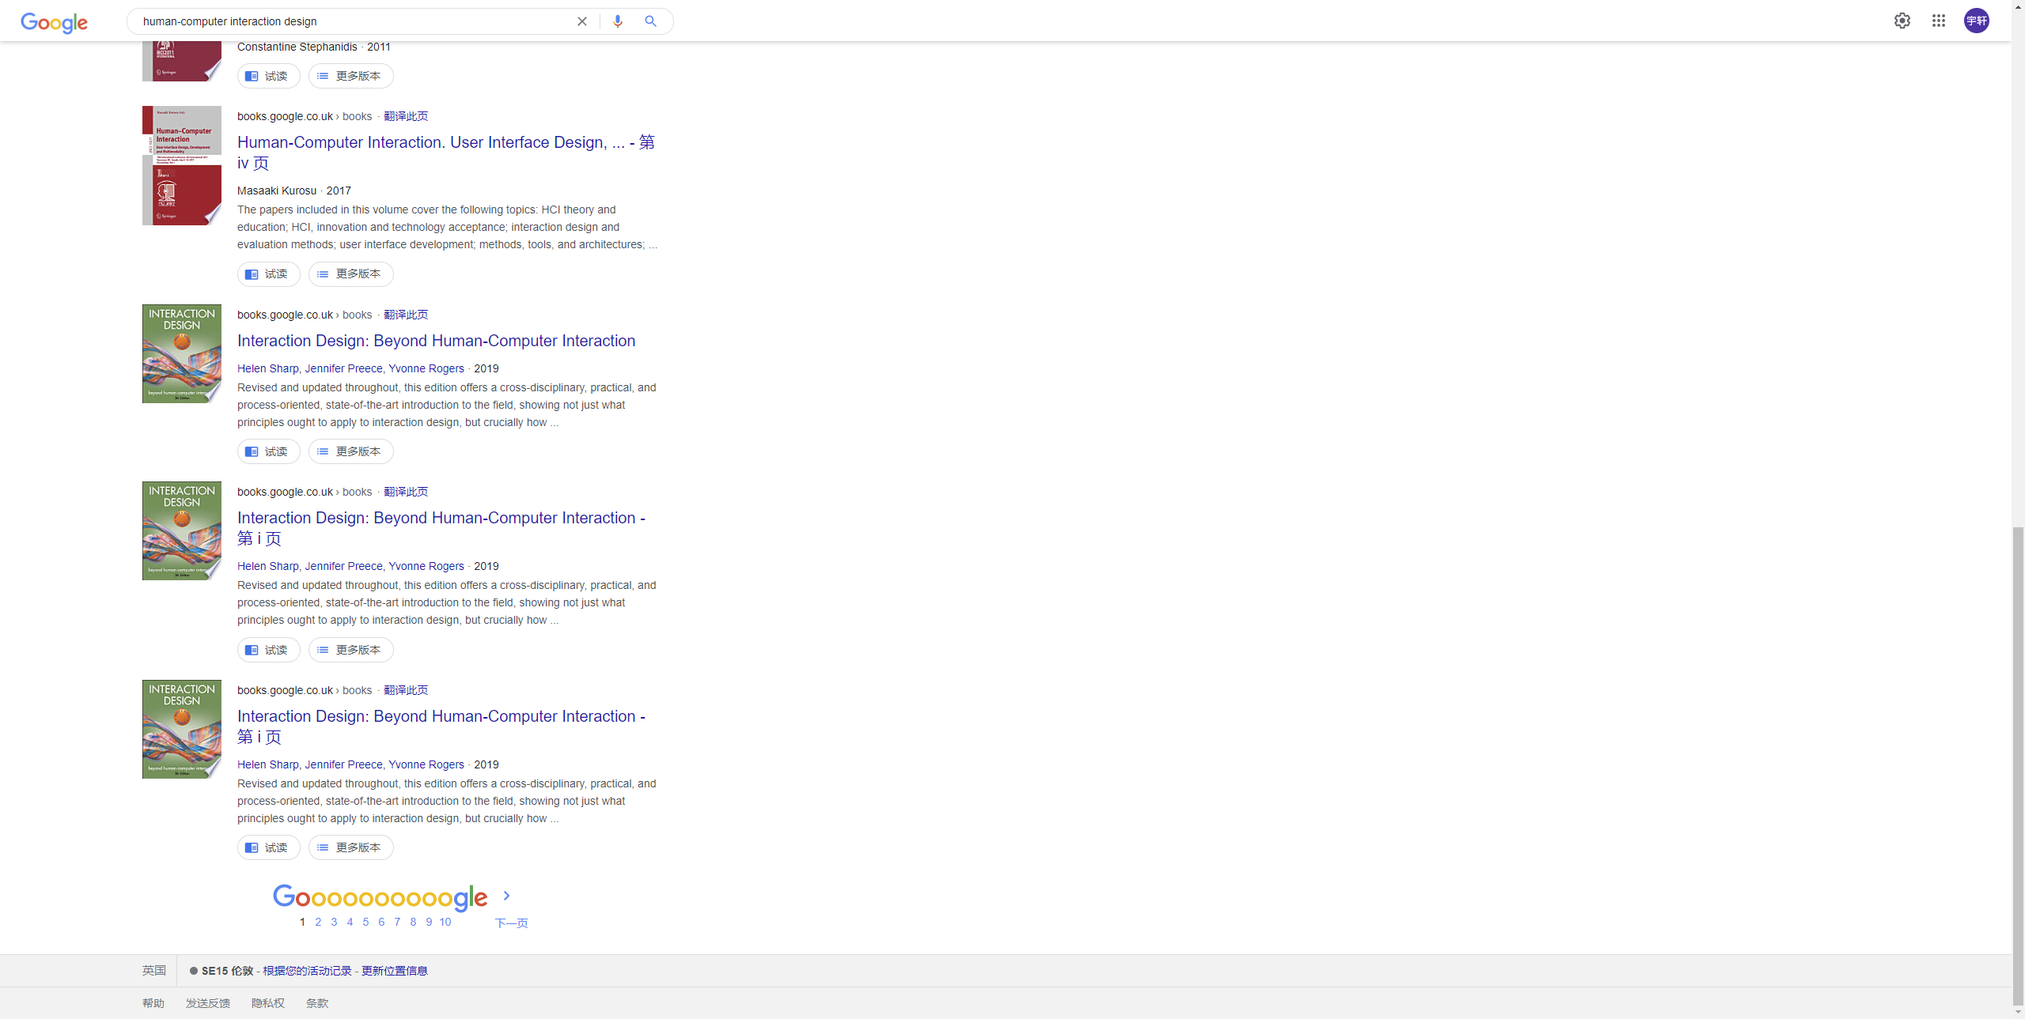

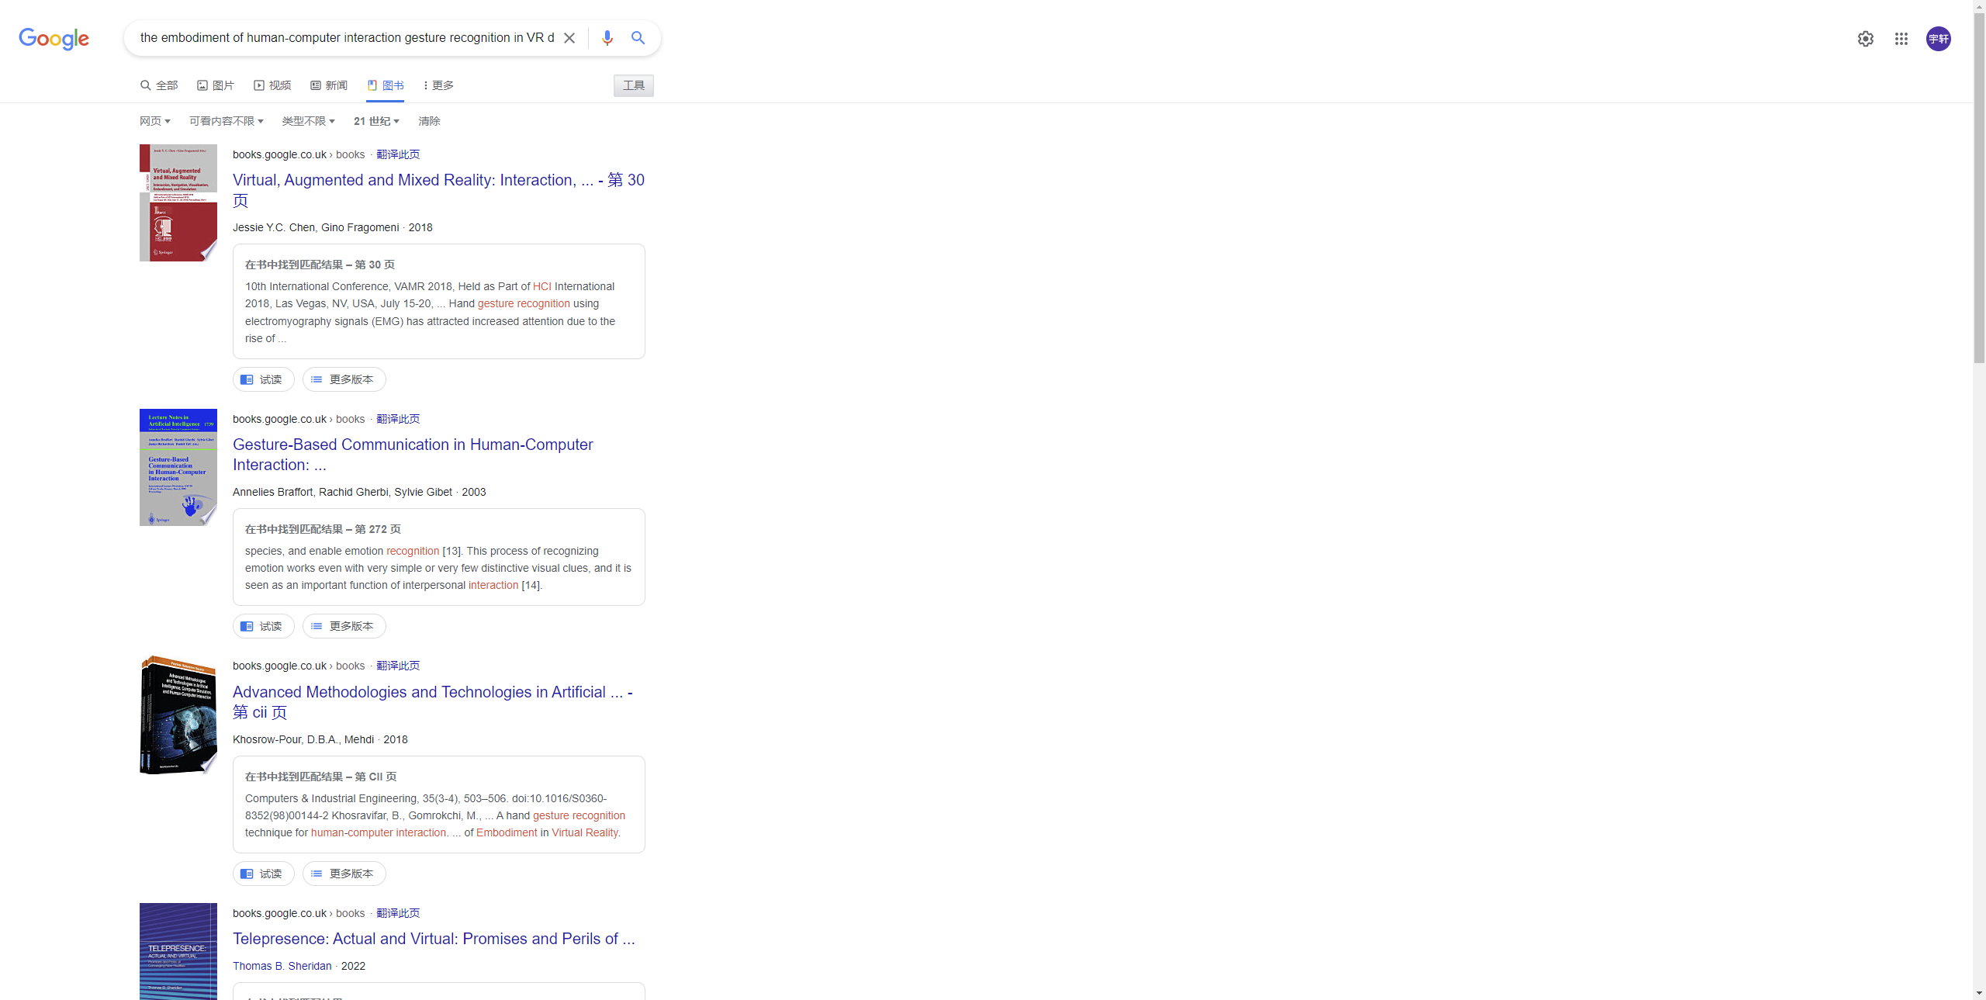

After reading how Helen Newing documents her article search and trying it, I think I have a clear logic about how to search for the papers than before. Especially when there are few search results, I can choose to change keywords to expand the search range. When there are many search results, I can change the topic to be more specific, and select time classification to narrow the range. In addition to refining by time, there are some other options to choose from in classification, which can help me to narrow the range. For example, human-computer interaction is a popular topic, so there are many articles on this topic. However, it is too broad. Therefore, using it to search is not a good choice. I think it is important to be specific when searching papers, and sometimes the search results are too few, then I can expand the scope. So I think concrete keywords are better. In addition, classification can also help me to select papers.

****Assignment Part 2****

**The new space station is called 'Indispensable Us', the environment needs diversity and respect each other. In the space station, each crew is different, including their physical appearance, and these differences happen to be their own unique skills and talents. Maintenance of the space station requires the abilities of everyone, each crew is indispensable.**

**Every crew’s job is to establish a better space station, such as construction, atmosphere, environment and so on. It means everyone is the important part of the space station. They need to work with each other and based on their unique abilities, each crew have different jobs and responsibilities. Therefore, each crew needs to improve their abilities and improve themselves. Crip technoscience can help them to enhance their capabilities. For example, if a crew member has a unique voice, crip technoscience can help her become a vocalist, and help her gain confidence. On the other hand, this way can create more possibilities and diversity for the space station, every crew will feel that their unique abilities are needed, and they will get a sense of accomplishment in the process.**

**Furthermore, in the process of cooperation, they will get more understanding and giving respect for each other, which can increase cohesion for the space station. So everything is peaceful in the environment, there is no war, no crisis, and the atmosphere is harmonious.**

**During the selection process of the crew, Indispensable us values individual skills and attitudes rather than their physical appearance, background or social status. This space station needs more people with diverse abilities. Each crew with differences are not discriminated against, they will be** embraced **and get respect, and get help from** crip technoscience. In addition, these people also need to have good quality. They will not be required to have a high degree, but they will be required to have volunteer experience, and pursue equality and respect for others. These qualities are the key to making the atmosphere of the space station. Furthermore, effort and diligence are also essential. Effort and diligence will allow the crew to improve their abilities and provide more help to the development of the space station. For example, musicians bring good music to the space station and create a better atmosphere, architects help everyone build their buildings, and designers will design different kinds of products according to each person's situation.

Therefore, in this team, everyone has a different background and comes from different countries, regions and beliefs, but they don't discriminate or make fun of others, equality and harmony are the norms here. Additionally, the crip technoscience can help each crew get confidence, make contributions and feel a sense of achievement. It can help them to create an equal relationship on the space station and help each crew unleash their potential.

In "Indispensable Us", everyone is different, but these differences are respected by all of the rather than erased, and crip technology not only brings technical to help them improve themselves but also supports them mentally.